
Secure Justice AI
"Empowering Legal Aid Organizations to Serve 50% More Clients"
IT/AI
in a Box
The First Integrated Technology Platform to Transform Legal Aid

CONSORTIUM PARTNERS
- lawfirmaiexpert.com / TrialLift.com
- cognifysolutions.ai
- prevent-ransomware.com

92% of Civil Legal Problems Go Unsolved—We Can't Lawyer Our Way Out

92%
Over 60 million Americans are effectively priced out of the justice system.
Legal aid organizations meet only 24% of total demand.
U.S. ranks 107th of 142 countries in affordability and accessibility of civil justice.


of civil legal problems receive inadequate or no help
"We will never be able to 'lawyer ourselves' out of this access-to-justice crisis."
— Scheree Gilchrist, Chief Innovation Officer, Legal Aid of North Carolina


Legal Aid Organizations Adopt AI at 2X the Rate of Big Law
Source: Everlaw, NLADA, Paladin, LawSites Survey (2025) — 112 legal aid professionals
17%
estimate AI could help them serve 50% or more additional clients
88%
believe AI can help address the access to justice gap
90%
of legal aid professionals want to use AI to serve more clients

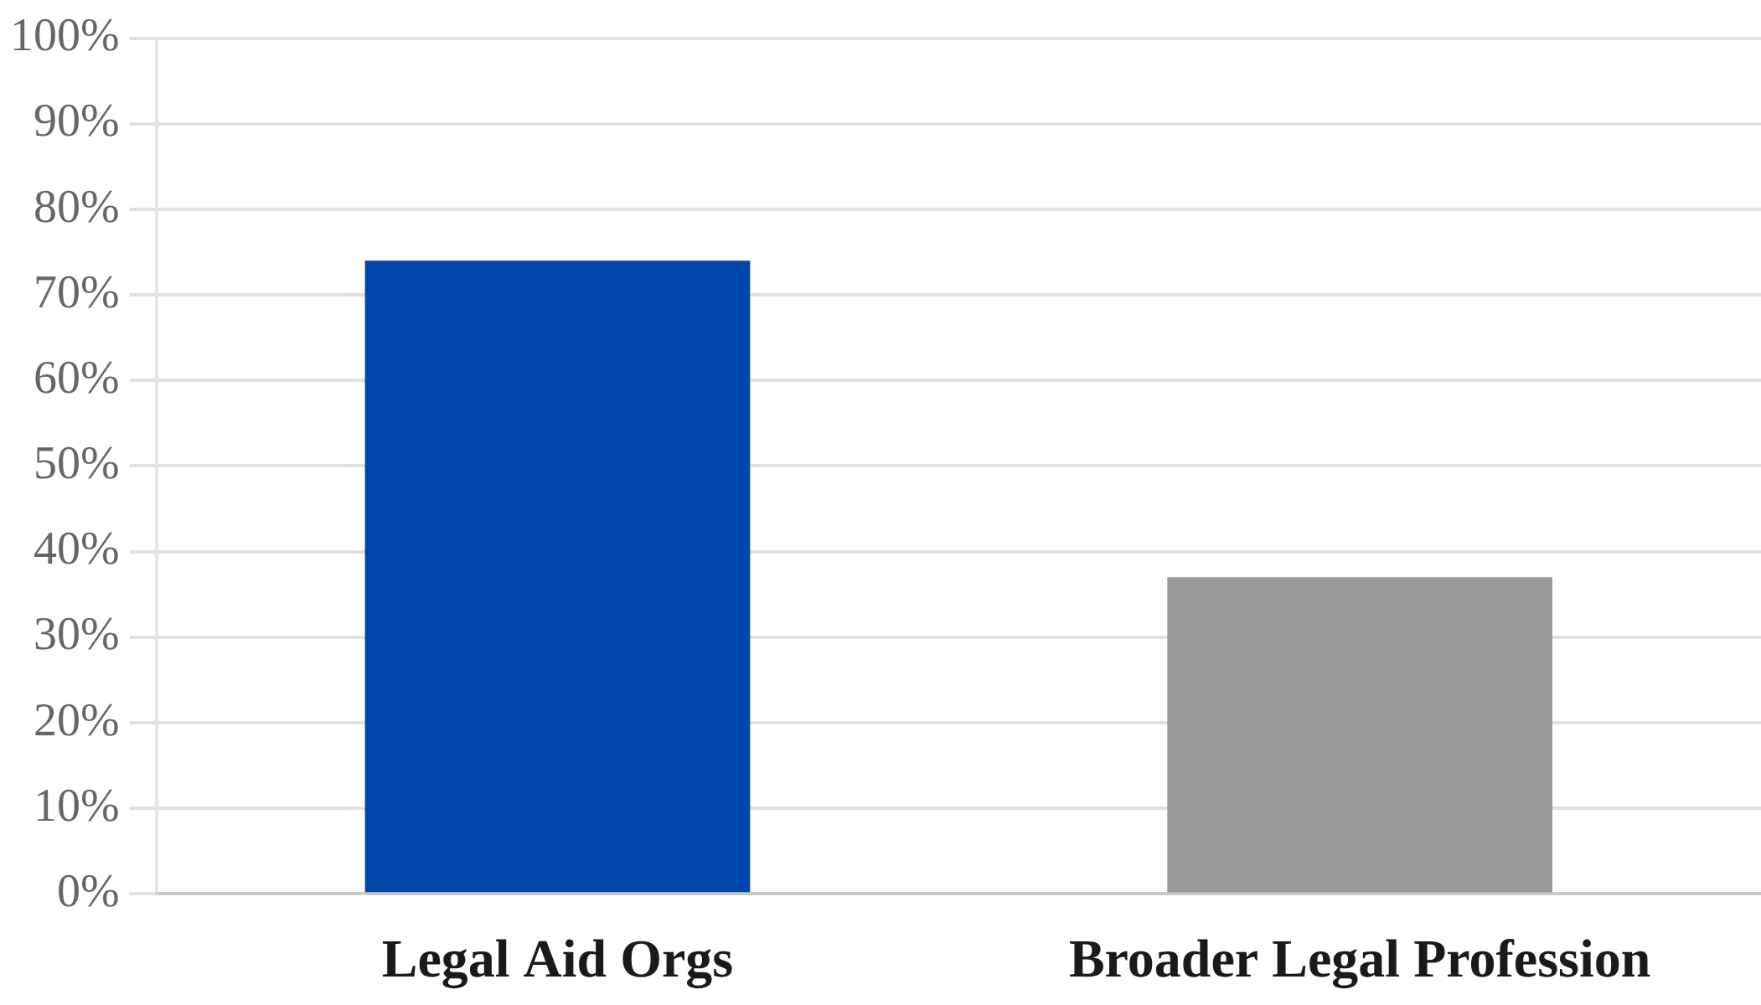
AI Adoption Rate (2025)

LSOs Are Drowning in Disconnected Point Solutions

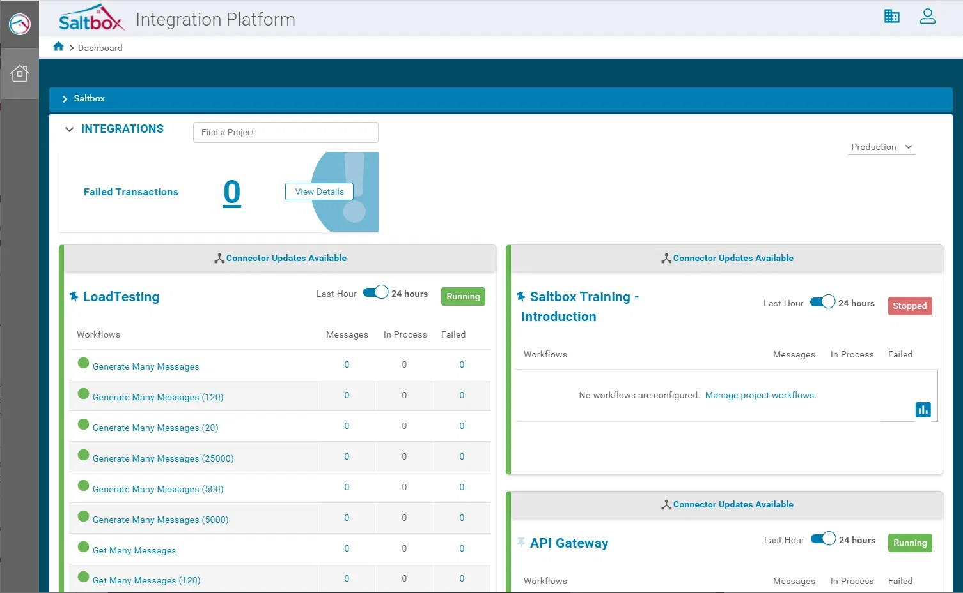
- Fragmented Patchwork: Tools don't talk to each other, creating data silos.

The Current Reality: A Tangled Web of Disconnected Tools
- Scattered Knowledge: Key materials live in isolated databases, internal drives, and static repositories.
- High Friction: Attorneys waste hours hunting for answers across pricey, disconnected platforms.
- Resource Drain: Require 300+ staff hours or expensive external vendors.

THE RESULT
Duplicated effort, critical delays, and dangerous security vulnerabilities.

Every Current Offering Leaves Critical Gaps Unfilled
VENDOR | WHAT THEY OFFER | WHAT'S MISSING
Paladin | Pro bono matching & case management | × No IT  infrastructure, cybersecurity, or AI research
Relativity | Free eDiscovery (requires law firm partner) | × No cybersecurity, governance, or turnkey deployment
Everlaw for Good | Litigation platform | × No comprehensive IT, AI  governance, or cybersecurity

VENDOR | WHAT THEY OFFER | WHAT'S MISSING
Lone Star Juris | AI research chatbot | × Single-purpose; requires 300 staff hours to build (DIY)
IT/AI in a Box | Complete integrated solution | ✓ Comprehensive: AI + IT + Cyber + Governance


Introducing IT/AI in a Box
The First and Only Comprehensive, Turnkey IT and AI Platform for Legal Aid

AI-Powered Legal Tools
LAWFIRMAIEXPERT.COM / TRIALLIFT.COM
  - Advanced legal research chatbot with RAG (Retrieval-Augmented Generation)
  - TrialLift citation validation to combat AI hallucinations
  - Source-cited, fact-based answers that attorneys can trust

Comprehensive Cybersecurity
PREVENT- RANSOMWARE.COM
  - Complete IT infrastructure and security framework
  - Ransomware protection and data privacy assurance
  - Secure cloud hosting and network management

Integrated AI Governance
COGNIFYSOLUTIONS.AI
  - Responsible, ethical AI implementation framework
  - Compliance with ABA ethics rules and LSC standards
  - Change management and staff training

Integration Isn't a Feature—
It's the Entire Value Proposition

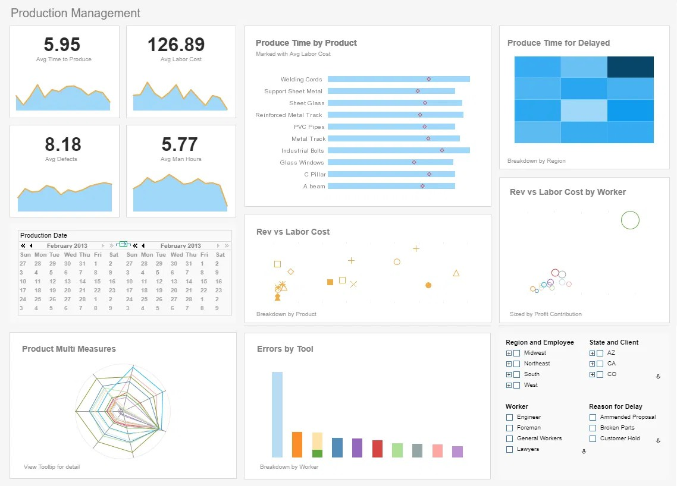
LSOs Are Not System Integrators
Legal aid organizations lack the time, resources, and technical capacity to connect fragmented tools.

The Cost of Fragmentation
Disconnected systems create security vulnerabilities, duplicated data entry, and administrative drag.

ONE PLATFORM ONE LOGIN ONE SUPPORT TEAM
UNIFIED EXPERIENCE DASHBOARD
Pre-built integration saves 300+ staff hours vs. DIY solutions
Based on Lone Star Juris development metrics

Five Leading Voices Confirm: This is What Legal Aid Needs Now


Angela Tripp
"These aren't just endorsements—they're the architects of legal aid's technology future."
LSC PROGRAM OFFICER FOR TECHNOLOGY
Manages the TIG program; validated replicability and cost-effectiveness in the Juris case study.

Adriene Holder
CHIEF ATTORNEY, THE LEGAL AID SOCIETY
Led team that won $1M Robin Hood AI Poverty Challenge, proving funding viability for AI tools.

Joanne Sprague
SENIOR DIRECTOR, EVERLAW FOR GOOD
Led survey revealing 74% AI adoption; emphasizes "responsible, ethical implementation at scale."

Bob Ambrogi
LEGAL TECH JOURNALIST, LAWSITES
Documented the 2X AI adoption rate in legal aid, validating immediate market readiness.

Kristen Sonday
CO-FOUNDER & CEO, PALADIN
Advocates that "LSOs deserve cutting-edge tools just like law firms have" to close the justice gap.

A Single-Purpose Tool Achieved This—Imagine What a Complete Platform Can Do

THE BASELINE:
LONE STAR JURIS
 Built AI-powered legal research chatbot using RAG architecture
$ Infrastructure cost: $2,000/year (with nonprofit credits)
 Development investment: 300 staff hours over 2 years
✴ Single-purpose tool requiring internal maintenance

SECURE LEGAL
 Comprehensive: Research + Citation Validation + Cybersecurity + Governance
→  Turnkey: Zero internal development required (vs.
300 hours)
 Standardized: Ready for rapid replication across 100+ organizations
 Integrated: One platform, one login, one support team

Enable Legal Aid Organizations to Serve 50% More Clients with the Same Staff


Automate High-Volume Tasks
01
Automate initial client intake, document summarization, and legal research.
Result: 30-50% time savings on administrative work.
02

Eliminate Inefficiencies
Centralized knowledge hub removes the need to hunt across disconnected platforms.
Result: Faster case resolution and reduced duplication.
17%
of legal aid professionals estimate AI could help them serve 50% or more additional clients.
Source: 2025 Legal Aid AI Survey

Free Attorneys for High-Value Work
03
Reallocate saved hours to court appearances, direct client advocacy, and complex strategy.
Result: More clients served, higher quality representation.


Match the $2,000/Year Benchmark While Delivering 10X the Value
ANNUAL COST STRUCTURE
Gross Cost
$5,000
-
Tech Credits
$1,000
-
Grant Subsidy
$2,500
=
Net LSO Cost
$1,500
VALUE COMPARISON
RETURN ON INVESTMENT
25:1
For every $1 invested, we generate $25 in social legal value.
Total Social Value Created
$250,000
(250 clients x $1,000 value)

SOLUTION | ANNUAL COST | WHAT YOU GET
Lone Star Juris | $2,000 | Chatbot Only
DIY Approach | $19,000+ | 1 Tool + High Labor Cost
IT/AI in a Box | $2,000 - $5,000 | Chatbot + Cyber + Gov + IT

$4.2M - $5.1M in Annual LSC Funding Available for Projects Like This

Our Perfect Alignment with LSC TIG Criteria
ELIGIBLE PROGRAMS
136 LSC-funded programs
AVERAGE GRANT
$130,000 - $155,000
NEXT CYCLE DEADLINE
March 2026 (Pre-App)

 Innovation: First integrated solution (no direct competitors).
 Impact: 50% capacity expansion target addresses justice gap.
 Quality: Adds citation validation, cybersecurity, and governance.
 Replicability: "In a Box" design is turnkey and modular.
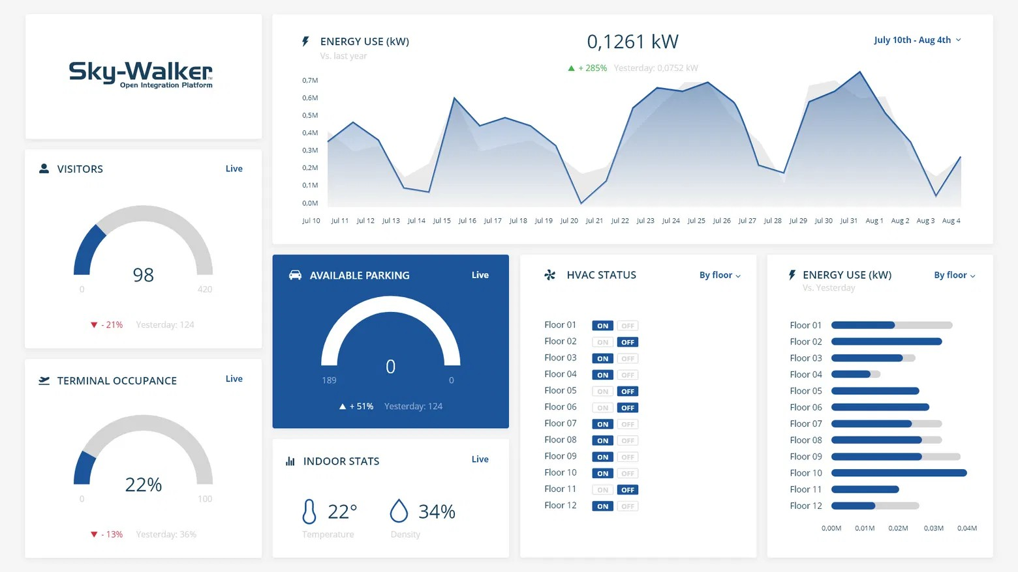
 Integration: Explicitly designed as an integrated technology system.
 Partnerships: Consortium model ensures built-in collaboration.
 Sustainability: Clear 3-year funding and revenue plan.

A Clear Path from Pilot to National Scale

Year 1
PILOT PHASE
$235,000
LSC TIG Grant
Nonprofit Credits Consortium In-Kind
$175k
$10k
$50k

GOAL
Deploy to 5-10 pilot organizations
Year 2
REPLICATION PHASE
$320,000
LSC SEA Grant
State Grants Revenue (10 sites) Tech Credits
$150k
$125k
$30k
$15k

GOAL
Scale to 25-50 organizations
Year 3
NATIONAL SCALE
$400k - $1.4M
Foundations
Revenue (25 sites) Robin Hood (Asp.)
$300k
$100k
$1M

GOAL
100+ organizations
3-YEAR TOTAL FUNDING POTENTIAL
$955,000 - $1,955,000

From Contract to Full Operation in Three Months—Not Three Years

PHASE 1: ONBOARDING  Weeks 1-4  - Technical needs assessment  - Staff training begins  - Data migration planning  - Security protocols established |  | PHASE 2: DEPLOYMENT  Weeks 5-8  - Platform installation & config  - Integration with CMS  - Comprehensive staff training  - Initial security audit |  | PHASE 3: GO-LIVE  Weeks 9-12  - Full platform activation  - Ongoing support & troubleshooting  - Usage monitoring  - First impact metrics collected


THE DIFFERENCE
Lone Star Juris took 2 years and 300 staff hours.
We deliver in 90 days with zero internal development.
Comprehensive Staff Training Included

Pilot Success → SEA Grant →

National Standard in 36 Months


REPLICATION MODEL
Year 1
5-10
Orgs
PILOT COHORT
Year 2
25-50
Orgs
EARLY MAJORITY
Year 3+
100+
Orgs
~ 20% OF MARKET
Vision: Become the standard integrated technology platform for legal aid nationwide.

"In a Box" Design
Standardized, turnkey deployment eliminates customization burden.

SEA Grant Pathway
Apply for LSC Sustainability, Enhancement, and Adoption grants post-pilot.

Comprehensive Documentation
Deployment playbook, training materials, and technical specs ready for export.

LSC AI Peer Learning Labs
Share learnings nationally to build demand for replication.

TARGET MARKET PENETRATION

Every Major Risk Has a Clear Mitigation Strategy


Technical Integration
MITIGATION: Phased development, extensive testing, and a dedicated technical coordinator.

Adoption Resistance
MITIGATION: Comprehensive training and privacy focus. (Note: 74% current adoption rate suggests low resistance).

Grant Dependency
MITIGATION: Diversified funding sources and a hybrid subscription model to build recurring revenue.
OUR PHILOSOPHY
"We don't just build technology; we build the safety net that protects it."

Competitive Response
MITIGATION: First-mover advantage and deep LSC relationships create a defensible moat.

Cybersecurity Incident
MITIGATION: Comprehensive security framework (prevent-ransomware.com), regular audits, and insurance.

Three Specialized Vendors, One Unified Vision


lawfirmaiexpert.com / TrialLift.com
AI RESEARCH & VALIDATION

〉 AI-powered legal research
〉 Citation validation technology
〉 Combats AI hallucinations

UNIQUE CAPABILITY
TrialLift citation validation
cognifysolutions.ai
GOVERNANCE & STRATEGY

〉 Responsible AI framework
〉 ABA ethics compliance
〉 Change management

UNIQUE CAPABILITY
Organizational readiness
prevent-ransomware.com
CYBERSECURITY & IT

〉 Comprehensive security
〉 Ransomware protection
〉 Secure cloud hosting

UNIQUE CAPABILITY
Legal aid-specific protocols
WHY THIS MATTERS
No single vendor has all three capabilities. Our consortium brings together complementary expertise that would cost $100,000+ to assemble independently.

Defining Success: Key Performance Indicators
We will measure the impact of the IT/AI in a Box pilot and expansion using four primary quantitative metrics aligned with LSC goals.

CAPACI TY E XPANS I ON  +50%  Increase in clients served per attorney  Through automation of intake and research tasks. | OPE R ATI ONAL E FFI CI E NCY  300 Hrs  Saved per attorney annually  Redirected to direct client advocacy and court time.
S E R VI CE Q U ALI TY  100%  Citation Validation Accuracy  Zero tolerance for AI hallucinations in legal drafts. | R E PLI CATI ON & S CALE  100+  Organizations by Year 3  Establishing a new national standard for legal aid IT.

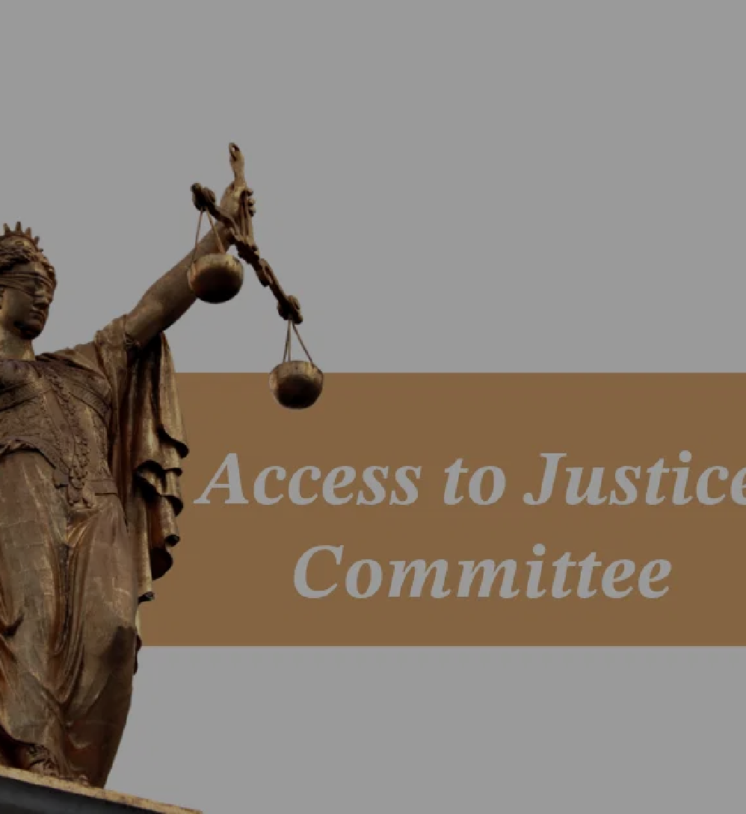
Join Us in Transforming Legal Aid
FOR LEGAL AID DIRECTORS
Become a Pilot Site
Gain early access to the platform and help shape the national standard.
Target: 5-10 organizations for 2026 launch.
FOR FUNDERS & FOUNDATIONS
Fuel the Expansion
Invest in a scalable solution with a proven 25:1 social ROI. Goal: $1.5M to reach 100+ organizations.
FOR TECHNOLOGY PARTNERS
Join the Consortium
Contribute specialized tools to the "In a Box" ecosystem. Opportunity: Integrate with a national platform.
The technology is ready. The need is urgent.
The time is now.
Let's close the justice gap together.

Ready to Transform Legal Aid?
Let's discuss how IT/AI in a Box can work for your organization.

[Primary Contact Name]
CONSORTIUM LEAD
✉ contact@it-ai-in-a-box.org
 (555) 123-4567
✶ www.it-ai-in-a-box.org

THE CO N SO RTI UM
lawfirmaiexpert.com cognifysolutions.ai prevent-ransomware.com

